

For More Info



**9090 20 6060**

**4**

**MONTHS**

**COURSE**

**DURATION**

COURSE FEE

8000/-

24000/-

**ONE SHORT**

**INSTALLMENT**

OR

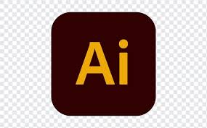

COURSE OUTLINE

Design Study

Logo Designing

Logo Designing

Vector Tracing

Photo Editing

Banner Ads Design

Business Card Design

Flyer, Poster and Brochure Design

Skin Retouching and Manipulation

Social Media Design

**BECOME A PROFESSIONAL**

**GRAPHIC**

**DESIGNER**

